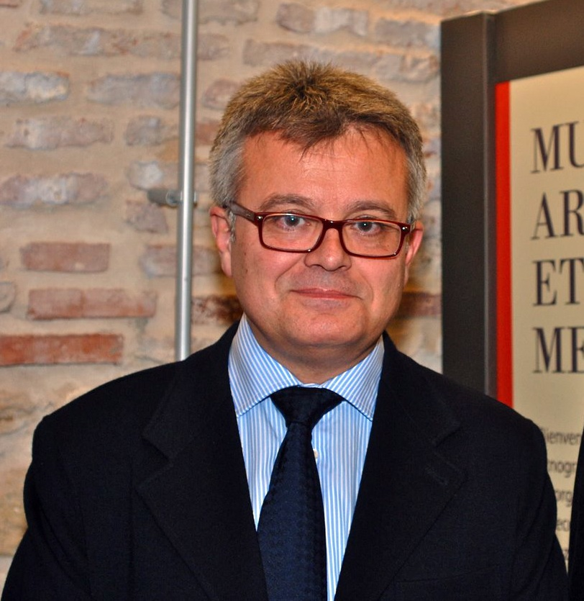

A. INFORMATIONS PERSONNELLES
Prenon - nom | Antonio BRAVO- NIETO
Num. identification de chercheur |  | Researcher ID | H-9527-2015
 |  | Código Orcid | 0000-0003-4475-4501

He divides his professional activity between teaching and research. He has a doctor’s degree in History of Art (1995), he is permanent member of the Academia Andaluza de la Historia (2013). He holds the position as a member of the Real Academia de Bellas Artes de San Fernando (2000), of the Real Academia de la Historia (2001) and the Real Academia de Bellas Artes de San Telmo. He was part of the department of History of Art of the Universidad de Malaga (Spain) for 6 years and throughout various courses he’s been a visiting professor in the Ecole Nationale d’Architecture de Tetouan (Morocco).

RÉFÉRENCES ACADÉMIQUES ET SCIENTIFIQUES
Id REF (SUDOC): http://www.idref.fr/097537543
ORCID-ID (0000-0003-4475-4501): http://orcid.org/0000-0003-4475-4501
RESEARCHER ID (): http://www.researcherid.com/rid/H-9527-2015
VIAF (ID 7267952): http://viaf.org/viaf/7267952/
ISNI (0000 0000 5952 0351): http://isni-url.oclc.nl/isni/0000000059520351
WORLD CAT IDENTITIES: http://www.worldcat.org/identities/lccn-nr93-42399/
Google Scholar: https://scholar.google.es/citations?hl=es&user=pi5R4Z0AAAAJ
Academia.edu: https://uned.academia.edu/AntonioBravoNieto

